

**The Key Steps to Begin Customer Journey Mapping**

Published 12 August 2021 - ID G00755690 - 14 min read Financial Services Business Leader Research Team

[Initiatives: Financial Services Business Leadership and Strategy; Financial Services](https://www.gartner.com/explore/initiatives/overview/44817) Customer Experience, Talent and Delivery

Customer journey mapping has become a popular way to understand customers from their perspective, but many firms struggle with how best to start. Financial services leaders can use this research to understand the critical preceding steps in the journey mapping process.

**Overview**

Financial services leaders are increasingly designing strategies to be more customer­centric, and many seek to do so by utilizing customer journey mapping. But that term is unclear, and some firms have struggled to define it and create a foundation that sets them up for success. Unorganized journey mapping processes can lead to a poor understanding of customers' real experiences, which in turn, informs poor decision making that fails to make a client impact. In effect, journey mapping done poorly is worse than not doing it at all. Financial services leaders can use this research to understand the three critical preparation steps they must take to create a sound foundation for a new customer journey map.

Key Findings

* Financial services firms that align their data strategies to the creation of journey maps will better understand their customers and can create products and services conducive to desired customer outcomes.
* Firms that create a cross-functional collaborative environment facilitate the use of broader varieties of data. This process will ultimately enrich journey maps.
* Persona building can lead to more empathetic decision making by bringing customer data to life and creating a realistic view of key customers that resonates with employees.

Recommendations



Financial services leaders in charge of CX strategies who use journey mapping should:

* Work across organizational silos that prevent information sharing between business functions to build a holistic view of customers.
* Provide staff with journey maps to help them think through how they contribute to customer experiences.
* Create transparency around the journey mapping process to help staff understand the end-to-end customer journey and generate stakeholder buy-in for customer experience solutions.
* Build personas that enable staff to create and deliver better customer experiences for key customers.

Introduction

Many financial services firms use customer journeys and personas to deliver a better customer experience (CX). For example, in Gartner's 2Q21 Financial Services Business Priorities Tracker, 96% of financial services business unit executives indicated "creating and refreshing products to address changing customer needs" was a priority for them either now or sometime through 2022-2023. However, only 49% were highly or extremely confident of their ability to achieve this goal. For financial services institutions that have yet to begin journey mapping, that are struggling to do so or that are having difficulties driving adoption, this research will serve as a foundational guide to get started or course correct.

Defining Customer Journey Mapping

In practice, journey mapping is a way of using customer data to create a visual, chronological representation of the processes consumers undergo to accomplish a goal. Many firms use journey maps as a tool to accurately portray customer experiences. While journey maps vary in appearance depending on the targeted customer, they should not be constructed to identify only where the firm and customer touch. To do so fails to consider the emotions, thought processes and experiences that precede and follow customer interactions with the firm. Keep in mind: Customers do not exist to transact with the firm, but rather the firm exists to serve the customers.

For example, the customer journey for a mortgage begins long before customers' initial contact with a financial provider, before they even realize they need to apply for a loan. Customers looking to apply for a mortgage do not make this decision when they walk into a branch or log onto their financial providers' online portals. Instead, the mortgage journey truly begins whenever customers enter a financial and lifestyle state where they can begin thinking seriously about buying a home. To accurately map out the customer journey, firms must begin with the lived experiences that lead customers to discover their need.



When constructed from the customer's point of view, a journey map may not describe the systems the firm typically thinks of when it considers how needs are met and does not concern itself with purchases, as such. But building out the customer journey can unearth powerful touchpoints, opportunities and potential customer outcomes. Customer journey maps are not linear; they involve various twists and turns reflective of the customer's thought process (see Figure 1). By limiting the focus to the buying cycle, many firms overlook the critical experiences that move customers from one stage of their journey to the next.

Figure 1: The Customer Journey

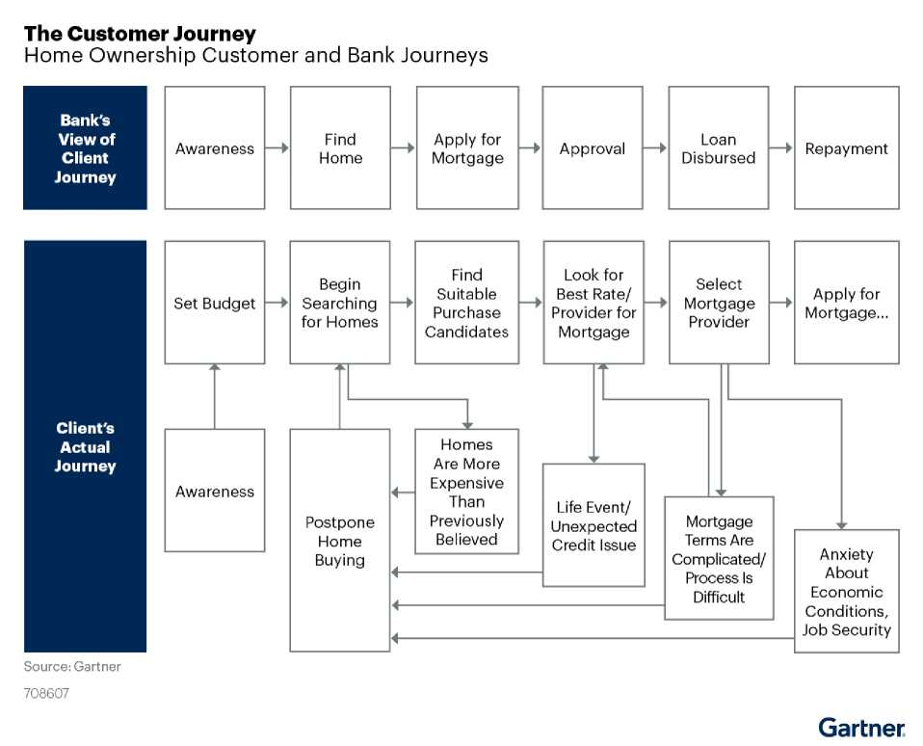

Understanding the customer journey's complexity can help firms identify and navigate customers' desired goals and the emotional drivers behind their product selection.

Customer journey mapping organizes customer data into a story of how customers identify their financial needs and come to interact with the firm. Financial services leaders use journey mapping to better understand their customers and to identify areas where they can improve CX. By tapping into customer data, firms can piece together each step in the customer life cycle and the critical and emotional points along the way. Using customer data for journey mapping creates an opportunity for firms to:

* Identify customer pain points.
* Understand CX trends.
* Understand the emotional drivers behind customers' product selection.
* Develop and improve products to help customers feel supported by their providers.
* Tailor CX to different personas.
* Improve innovation.

Firms that struggle with their journey mapping efforts do so for a variety of reasons. Maps that are too generic fail to identify true customer objectives. This makes it difficult to identify and prioritize critical CX moments that matter and provide proof of concept for CX strategies. In other cases, leaders may be unfamiliar with the discipline of journey mapping but implement something that feels like it to stay current with industry trends. This uninformed approach may not add much value to the firm. These examples represent common mistakes firms make and, of course, there are others. But the reason most firms struggle with journey mapping stems from one cause: failing to properly prepare internally for the journey mapping process.

Laying the Foundation for Success

Overlooking critical first steps in preparing and planning the journey mapping process leads to inaccurate views of customers. Because any successful effort at mapping journeys requires certain assets to be in place, firms should first assess their ability to support journey mapping. To create a foundation that supports journey mapping activities, firms should focus on the steps shown in Figure 2.

Figure 2: Preparing for Customer Journey Mapping

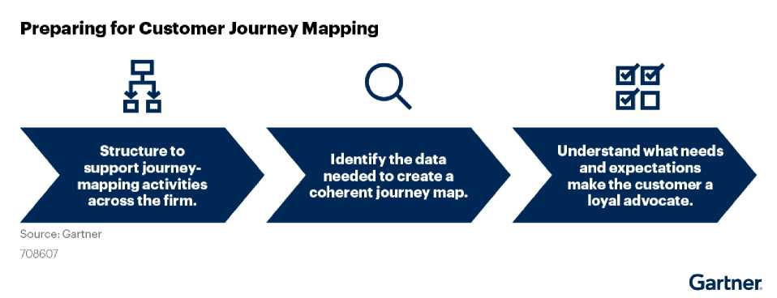

Integrating a Journey Mapping Data Strategy

Gathering and managing customer data is a core component of journey mapping. Firms have a wealth of customer data from existing sources such as payments accounts, customer transactions, contact center software, compliance activities, CRM systems and even social media posts that can be used to map interactions at a customer level. However, financial services leaders often struggle to maximize the value of their data assets.



For example, in Gartner's 2Q21 Financial Services Business Priorities Tracker, 98% of financial services business line leaders consider "modernizing legacy systems and technology to meet customers' digital needs" a priority for them either now or sometime through 2022-2023. However, only 33% are highly or extremely confident in meeting that priority. Without a strategy to transform data into insights, journey maps lose their accuracy (and therefore authority) to inform decision making.

Each firm may choose to manage its customer data differently, but the absence of a formalized process to collect, organize, understand and distribute customer data can lead to diminished data quality, making it hard to achieve customer-centric, data-driven strategies. To better organize and manage their data, some firms:

* Create centers of excellence (COEs) to improve analysis capabilities.
* Use data analytics technology to harness alternate data sources and get a more holistic picture of the customer.
* Aggregate customer data into a CRM system to centralize information for all business lines.

However, firms do not need to increase or change their investments solely for journey mapping. Taking stock of existing customer data can help firms create or improve journey maps while being resource-efficient. Figure 3 shows an example of how business leaders can link data sources to their use in the construction of journey maps.



Figure 3: Ways to Gather and Manage Customer Data

Ways to Gather and Manage Customer Data

Example Information Sources and Uses

Customer Contact and Engagement Platforms

What customer needs are not being met?

What are the points of friction that cause customers to call?



CRM

What is the retention and lifetime What are the greatest

value of different personas? opportunities for cross-sell, upsell

and engagement?

How do effective offers change based on the stage in the journey?

Digital Marketing Hub

What offers generate the greatest response?

Existing Customer Research What are the important decision

How do customer expectations and needs change in different stages of the journey?

factors and preferences for different personas?

Source: Gartner

708607



Gartner

Having an organized data strategy can determine the success of customer journey mapping efforts, but no data strategy can exist on its own. Before beginning to map the customer journey, it is critical firms ensure that (as much as possible) their data is correct, comprehensive and representative of customers, consistent and granular. Ultimately, any approach has to integrate with a broader data strategy.

**"We record data from the very beginning. It allows managers and senior leadership to have more visibility, and it creates a data archive"**

— *EVP, North American wealth management firm*

Customer data reaches into all corners of an organization, so the importance of collaboration cannot be overstated. Cooperation between business functions on sharing and organizing customer data helps ensure data-driven decision-making processes are sustained for the future.

Building Cross-Functional Alignment

Gartner, Inc. | G00755690 Page 7 of 16

**"We had a narrow definition of what the end-to-end experience was. We were doing everything in silos, and that wasn't working"**



— *Operations Executive, North American retail bank*

Journey mapping efforts require collaboration. Business functions like sales, marketing and IT each understand a snapshot of the customer. An end-to-end journey can be created only once the disparate pieces of data are combined (see Figure 4). Differing perspectives on the customer lead to difficulty building consensus around:

* Which pain points are the most important to solve
* Which initiatives should be pursued to improve the customer journey
* How selected initiatives should be sequenced into the customer journey

Without collaboration to enable this, a journey map can create inconsistent or inaccurate views of the customer.

Journey Mapping Within Business Silos

Siloed Understanding of the Customer

Figure 4: Journey Mapping Within Business Silos



**Frontline Data Operations**



CX Marketing IT



Credit Product Customer

Underwriting Development Support

Source: Gartner

708607

Gartner

Banks that do not collaborate or communicate across business functions will struggle to drive customer centricity in CX initiatives. Financial services leaders who confine themselves to only solving customer pain points by designing journey maps within their individual silos often miss important CX pain points or opportunities. Firms that successfully overcome this challenge create an environment where teams share diverse perspectives and data to support CX — in short, they collaborate. This can also include standardizing the journey mapping process across the firm, which reduces complexity by eliminating duplicate or conflicting customer journey maps. By creating a uniform process where information is shared across silos, business leaders can mitigate errors and improve efficiency. Firms have standardized journey mapping by:

* Aligning business units to key phases of the customer journey
* Creating a COE or business unit dedicated to managing customer journeys
* Consolidating customer journey maps that share consistencies
* Centralizing customer data (e.g., data hub, CRM system) to improve firmwide accessibility

Ga

e

Case in Point: Centralizing CX Efforts to Be More Outcome-Focused (National Bank of Canada)

NATIONAL National Bank of Canada (NBC) found its CX initiatives



BANK were not leading to the expected experiential outcomes.

And when it tried to launch new solutions, NBC employees had to do considerable rework and redesign based on end-user feedback. As a result, NBC created its "experience factory," a new business unit that brings together stakeholders, including business line leaders, customers and frontline staff.

The experience factory executes the firm's goal to be the fastest and easiest bank for customers to do business with across all its business lines. To deliver products that align with customer journeys, the experience factory uses input from the voice of the customer to create an initial design for the journey of a particular experience. Then the experience factory, its clients and other stakeholders collect feedback and iterate until an end-to-end customer journey forms.

Once complete, journey maps are displayed on the experience factory's wall to guide product teams in developing solutions. The experience factory also keeps leadership informed about current CX priorities, successes and failures by engaging senior stakeholders (see Figure 5).

Read the full study: [Case Study: Customer Experience Design Factory (BNC)](https://www.gartner.com/document/code/712274?ref=authbody&refval=) Case Case in Point: Optimizing Data Infrastructure for Collaboration (TD Bank)

TD Bank's wealth management line of business had an organizational structure oriented around products, with silos dedicated to distinct product areas. Data was



Bank



NATIONAL

BANK

OF CANADA

Source: Adapted from National Bank of Canada

708607

Gartner

National Bank of Canada's Experience Factory

Inputs to Designing a Journey Map



ft ft rftf rftf M

* Client emotions
* Internal stakeholders
* Associated key initiatives
* Pain points
* Aligned products and services
* Client personas



Figure 5: National Bank of Canada's Experience Factory



Experience Assigned Internal Employees Clients

Leader Experience Stakeholders

Designer

organized across various platforms in silos with little communication between them, which led to gaps and variations in customer data. However, TD Bank realized it needed to change its product-oriented approach to meet its goal of offering more holistic advice to clients by orienting around client priorities instead. To address this, TD Bank put the client at the center of its technology ecosystem by centralizing client data on a platform that facilitates needs discovery, supports thought leadership and expertise, and is simple and straightforward to use.

TD Bank clients interface with a single platform spanning different applications that talk to one another and reinforce a goals-based approach. This puts all the client's goals in one location, which will influence the client's future interactions with the bank. Client data is recorded from the start of the client journey and is fed into a single data layer across the platform, making client details uniform across CRM, planning and investment platforms, and reporting. This ensures clients receive consistent service regardless of when they contact the bank (see Figure 6).

Ga



Figure 6: TD Bank's Customer Journey Mapping Structure

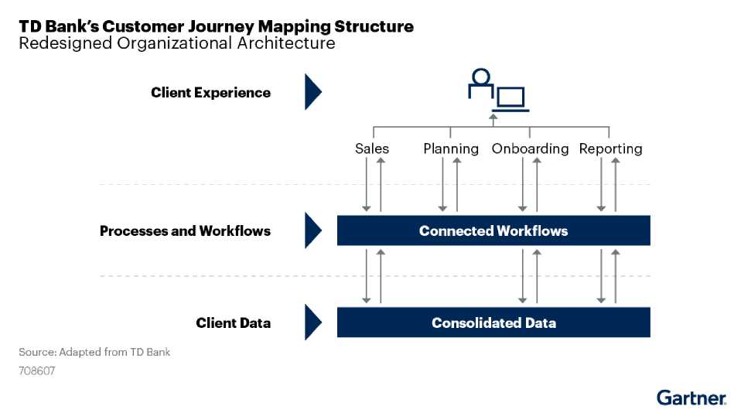

Scaling the Utility of Journeys Through Personas

Customers vary in expectations, experiences, goals and needs. Building a journey map that generalizes a single journey for an entire customer base fails to capture the relevant experiential details for real customers, and ultimately minimizes the benefit firms might realize through the exercise. But an economical approach is also necessary. One best practice is to build personas, which are fictional representations of key customer types based on common clusters of goals, needs and desired experiences.

Personas are semifictional characters, grounded in actionable qualitative and quantitative research, that uncover gaps in understanding customer needs and challenges. One of the benefits of customer personas is their potential to replicate and institutionalize the personal empathy that was historically part of human interactions. Using aggregate customer data, a persona of sufficient detail allows staff to understand the most critical needs of most individual customers. They tell customer stories about life experiences and have a way of humanizing data and, more practically, inform relatable and productive conversations with customers.

However, personas can be difficult to create without understanding what they should include. Personas help firms categorize customers based on common goals and experiences and highlight the diversity of customer points of view. They differ from segments, which are broader groups that aim to serve the highest number of valuable customers at the lowest cost (see Table 1).

Table 1: Differences Between Personas and Segments Segments Personas

Establish an overview of the customer base. Understand customers on a personal level.

Classify various types of customers into Account for psychographic differences

specific demographic groupings (e.g., asset among a customer base (e.g., values, class, age). attitudes, goals, interest, lifestyle).

Tailor messages, products and services to a Cut across segments and unify them into

unique portion of the customer base. fewer market targets by focusing on the

needs and values of only key customers.

Source: Gartner

Segments inform persona building, but personas group key customer needs and wants that affect how and why customers move from one stage of their journey to the next. Elements of a persona include:

* Goals
* Challenges
* Financial needs
* Lifestyle
* Attitudes
* Preferences and interests

Gartner has created a series of readymade retail banking and wealth management personas that financial services leaders can plug into their client experience journey maps [to find new ways of improving the customer experience. See the full study: Key Customer](https://www.gartner.com/document/code/744970?ref=authbody&refval=) Personas for Financial Services.

Case in Point: Creating Customer Profiles From Personas (Australia Post)

AUSTRALIA

Opost

Australia Post wanted to include the customer experience during its solution design and development process by incorporating IT more closely into CX work. By embedding customer journey mapping tools into its employees' workflow, Australia Post employees created customer personas that:

* Used realistic customer features to create employee empathy with individual customers' experiences through personas that include representative customer names, faces and priorities
* Used customer voice to convey a customer's needs and expectations in their own voice to help prevent employees from making faulty assumptions
* Gave insight into interactions by sharing how a customer interacts with the organization to provide visibility of how employees' day-to-day work actually impacts customers

Australia Post sought to help its IT team treat the customer personas like humans by using customer voice to make the personas as realistic as possible. Figure 7 shows what a typical persona profile would look like.

Figure 7: Australia Post's Personas

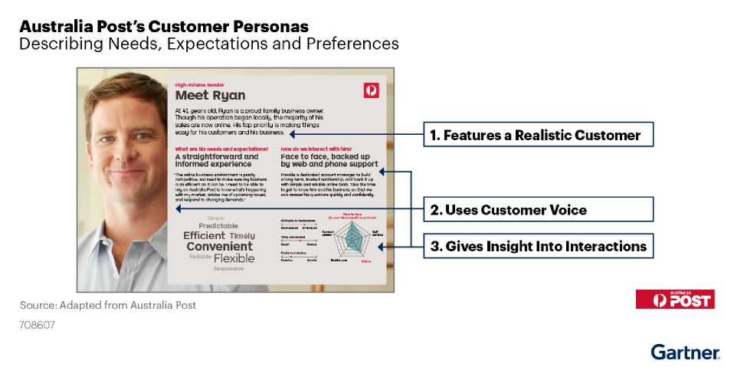

**Conclusion**



Preparing for successful journey mapping requires collaboration across business functions. Cross-functional collaboration encourages engagement across the firm and can help a firm become more customer-centric. While firms do not need to change their organizational structure to orient completely around customer journeys, engaging different business functions in the journey mapping process gives employees a clear look at how their work impacts customer outcomes. By using customer journey maps as part of CX efforts, financial institutions can best leverage customer data to understand the people they serve.

**Recommended by the Authors**

[Ignition Guide to Building a Data Governance Program](https://www.gartner.com/document/code/428122?ref=authbody&refval=)

**About This Research**

*The organizations profiled in this research are provided for illustrative purposes only, and do not constitute an exhaustive list of examples in this field nor an endorsement by Gartner of the organization or its offerings.*

This research draws from qualitative and quantitative research, as well as interviews with business line leaders, on customer journey mapping best practices.

Gartner's Financial Services Business Priority Tracker, May 2021 was conducted in 2Q21 to understand the key business priorities of FS business leaders, their views on future customer trends, and their sentiment around remote working. The survey was an online survey fielded from May 19 to June 16. The survey has 86 respondents who are business executives from Financial Services.

**Document Revision History**

The Key Steps to Begin Journey Mapping - 17 September 2019

© 2022 Gartner, Inc. and/or its affiliates. All rights reserved. Gartner is a registered trademark of Gartner, Inc. and its affiliates. This publication may not be reproduced or distributed in any form without Gartner's prior written permission. It consists of the opinions of Gartner's research organization, which should not be construed as statements of fact. While the information contained in this publication has been obtained from sources believed to be reliable, Gartner disclaims all warranties as to the accuracy, completeness or adequacy of such information. Although Gartner research may address legal and financial issues, Gartner does not provide legal or investment advice and its research should not be construed or used as such. Your access and use of this publication are governed by [Gartner's Usage Policy](https://www.gartner.com/technology/about/policies/usage_policy.jsp). Gartner prides itself on its reputation for independence and objectivity. Its research is produced independently by its research organization without input or influence from any third party. For further information, see "[Guiding Principles on Independence and Objectivity](https://www.gartner.com/technology/about/ombudsman/omb_guide2.jsp)."



Table 1: Differences Between Personas and Segments

Segments Personas

Establish an overview of the customer base. Understand customers on a personal level.

Classify various types of customers into specific demographic groupings Account for psychographic differences among a customer base (e.g., values, (e.g., asset class, age). attitudes, goals, interest, lifestyle).

Tailor messages, products and services to a unique portion of the customer Cut across segments and unify them into fewer market targets by focusing base. on the needs and values of only key customers.

Source: Gartner